20141013

https://jira.tcsbank.ru/browse/TS-634

Terentev Aleksey added a comment - Today 11:44 AM
IRS установлен на сервер sim (m1-sim).
создан CNAME .
ПО доступно по адресу - https://m1-irs:7906/

Software Depot home
https://h20392.www2.hp.com/portal/swdepot/index.do

https://h20392.www2.hp.com/portal/swdepot/displayProductInfo.do?productNumber=RSSWMBASE

Overview
About the HP Insight Remote Support Solutions

HP offers the following Insight Remote Support solution.

Insight Remote Support 7.x
Designed and optimized to remotely support up to 2,500 monitored devices and can be installed on a Windows ProLiant Hosting Device or a Windows Virtual Guest. Additionally, it can easily be integrated to work with a supported version of HP Systems Insight Manager.

Note: Insight Remote Support 7.x replaces Insight Remote Support Standard. If you're using version 5.x of Insight Remote Support Standard, see the Insight Remote Support Upgrade Guide for information about upgrading to 7.x.

HP Insight Remote Support 7.x provides remote support to certain devices under warranty, HP Care Pack Service or HP Support Contract, including Proactive Care contracts. Support coverage is subject to change, so check the current Insight Remote Support Release Notes for specific details. The HP Insight Remote Support solution can be downloaded at no cost from the HP Software Depot at:
http://h20392.www2.hp.com/portal/swdepot/displayProductInfo.do?productNumber=REMOTESUPPORT

Additional product information
Product #: RSSWMBASE
Version: -
Software specification:

https://h20392.www2.hp.com/portal/swdepot/displayProductInfo.do?productNumber=REMOTESUPPORT
Overview
About HP Insight Remote Support 7.x

HP Insight Remote Support 7.x is a software solution that enables reactive and proactive remote support to improve the availability of supported servers, storage, networking and printers.

HP Insight Remote Support enables enhanced delivery of your HP Warranty, HP Care Pack Service, or HP contractual support agreement. HP Insight Remote Support supplements your monitoring continuously to ensure maximum system availability by providing intelligent event diagnosis, and automatic, secure submission of hardware event notifications to HP, which will initiate a fast and accurate resolution, based on your product's service level. Notifications may be sent to your HP Authorized Channel Partner for on-site service, if configured and available in your country.

For more information about Insight Remote Support see: http://www.hp.com/go/insightremotesupport.

About HP Insight Remote Support 7.1
HP Insight Remote Support 7.1 has been optimized to support up to 2,500 monitored devices and can be installed on a Windows ProLiant Hosting Device or a Windows Virtual Guest. Additionally, it can easily be integrated to work in cooperation with a supported version of HP Systems Insight Manager and offers integration into Insight Online.

HP recommends that you read the documentation to assist during the installation. There are system prerequisites for both your Hosting Device and monitored devices that, if ignored, will prevent a successful installation and may require a full re-installation. For prerequisites and installation instructions, see the HP Insight Remote Support Quick Installation Guide available at http://www.hp.com/go/insightremotesupport/docs.

Additional product information
Product #: REMOTESUPPORT
Version: 7.x
Software specification: HP Insight Remote Support Version 7.1.0

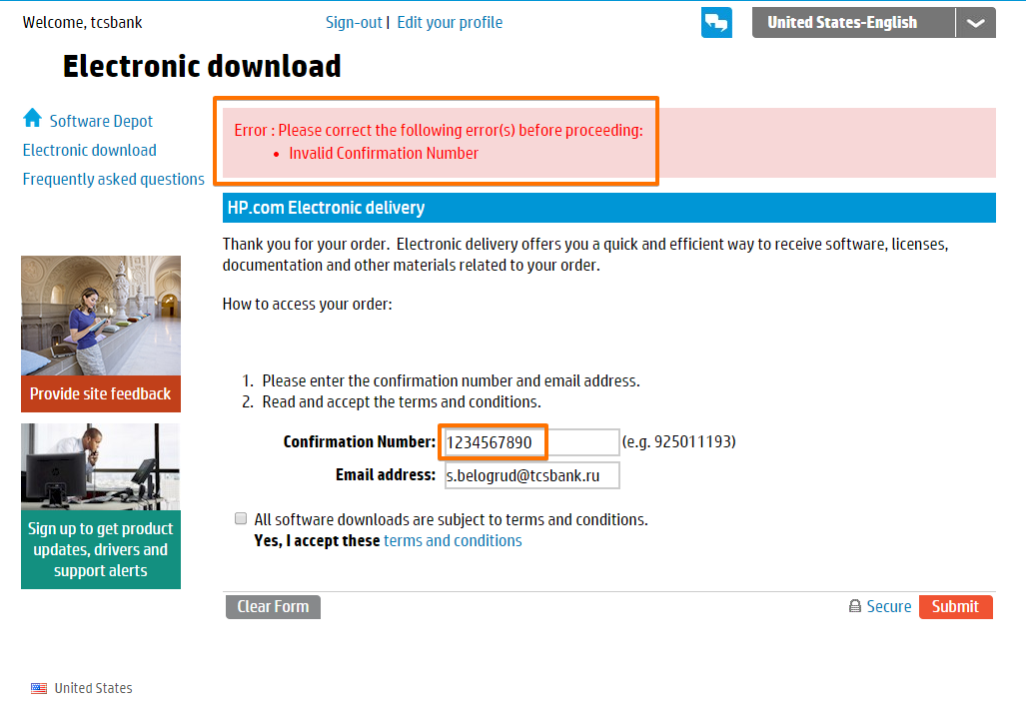

After several of hours I have received from Treentyev this email letter.
But I alread have gotten access even without this email.
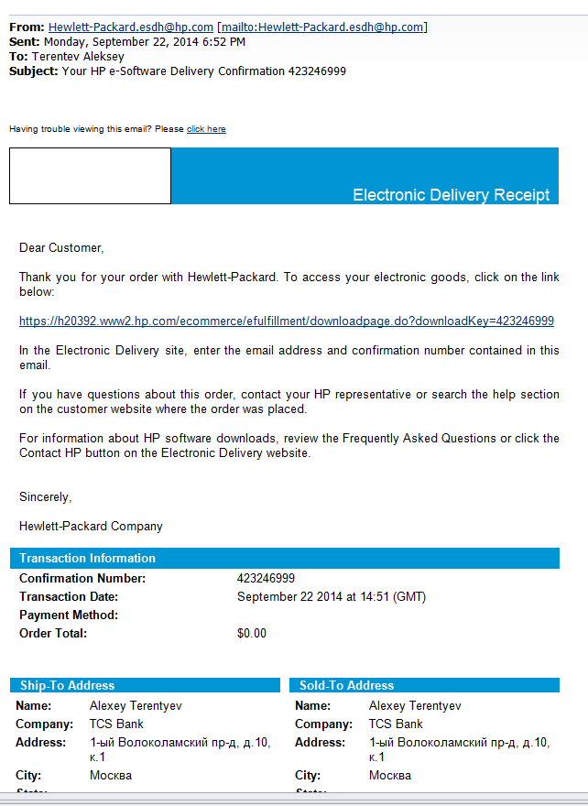
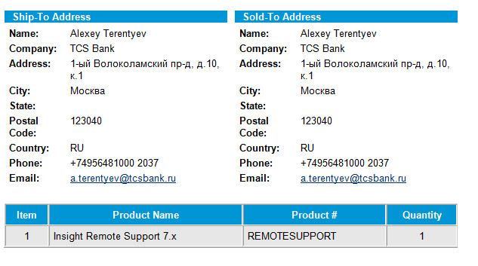

From: Terentev Aleksey
Sent: Monday, September 22, 2014 7:17 PM
To: Belogrud Sergey Vladimirovich
Subject: FW: Your HP e-Software Delivery Confirmation 423246999

From: Hewlett-Packard.esdh@hp.com [mailto:Hewlett-Packard.esdh@hp.com]
Sent: Monday, September 22, 2014 6:52 PM
To: Terentev Aleksey
Subject: Your HP e-Software Delivery Confirmation 423246999

Having trouble viewing this email? Please click here

Electronic Delivery Receipt

Dear Customer,

Thank you for your order with Hewlett-Packard. To access your electronic goods, click on the link below:

https://h20392.www2.hp.com/ecommerce/efulfillment/downloadpage.do?downloadKey=423246999

In the Electronic Delivery site, enter the email address and confirmation number contained in this email.

If you have questions about this order, contact your HP representative or search the help section on the customer website where the order was placed.

For information about HP software downloads, review the Frequently Asked Questions or click the Contact HP button on the Electronic Delivery website.

Sincerely,

Hewlett-Packard Company

Transaction Information

Confirmation Number: 423246999
Transaction Date: September 22 2014 at 14:51 (GMT)
Payment Method:
Order Total: $0.00

Ship-To Address
Sold-To Address

Name: Alexey Terentyev
Company: TCS Bank
Address: 1-ый Волоколамский пр-д, д.10, к.1
City: Москва
State:
Postal Code: 123040
Country: RU
Phone: +74956481000 2037
Email: a.terentyev@tcsbank.ru

Name: Alexey Terentyev
Company: TCS Bank
Address: 1-ый Волоколамский пр-д, д.10, к.1
City: Москва
State:
Postal Code: 123040
Country: RU
Phone: +74956481000 2037
Email: a.terentyev@tcsbank.ru

Item Product Name Product # Quantity
1 Insight Remote Support 7.x REMOTESUPPORT 1

http://www8.hp.com/us/en/business-services/it-services.html?compURI=1078312#.VCAENfnV85g

Insight Remote Support (Insight RS)

Spend less time solving problems and more time focusing on your business. Mitigate risk, reduce cost and keep your business up and running. Offload some IT tasks and actually do more with less.
Continuously monitoring your environment, this solution alerts you and provides up to 66% faster problem resolution and up to 95% first time fix rate. With near 100% accurate diagnostics, information is sent to HP call center staff, which can remotely log in and determine if the problem can be resolved immediately or if it needs an onsite visit. Break / fix support per the terms of your service agreement may be delivered by HP Support or your HP Authorized Service Provider.
When used together with HP Proactive Care service, you receive periodic proactive advice on areas of concern in your IT environment and reports. You also receive a superior call center experience by being directly connected to a technical expert.
HP Insight Online, which is located on HP Support Center can automatically display devices remotely monitored by HP Insight Remote Support 7.x (7.0.5 and higher). It allows you and HP / your HP Authorized Channel Partner to easily track service events and related support cases, view device configurations and proactively monitor your HP contracts and warranties from anywhere and anytime.
HP Insight Remote Support is available as a part of your valid HP warranty, HP Care Pack Service, HP Proactive Care, or contractual support agreement. Select from HP Insight Remote Support 7.0.8 (for environments with 1- 2500 IT devices) or HP Insight Remote Support Advanced (for environments with up to 3250 enterprise and mission critical IT devices).
Note: HP Insight Remote Support 7.0.8 is a replacement and an upgrade to devices previously supported by all versions of Insight Remote Support Standard 5.x, which are at end of support life.

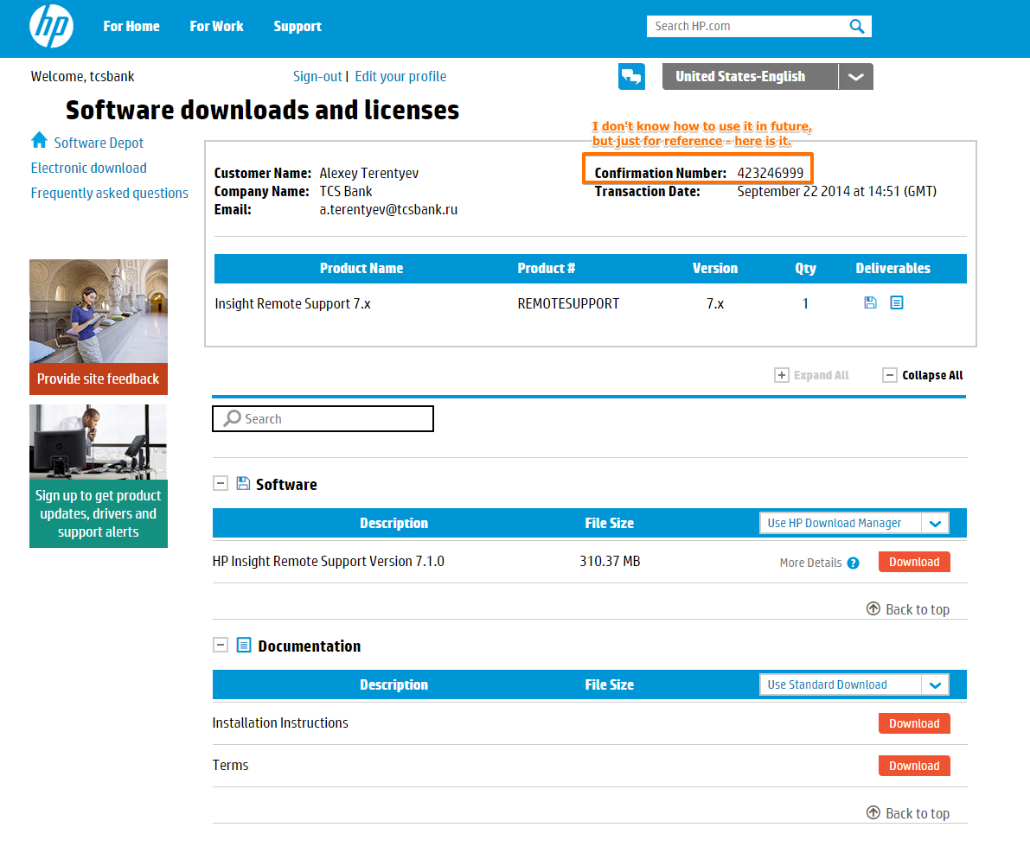
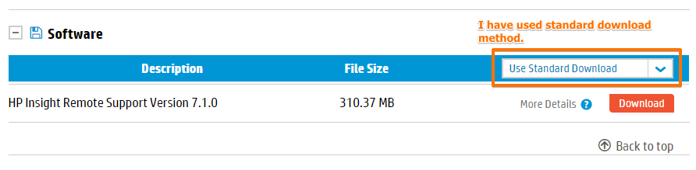

http://h30279.www3.hp.com/catalog_content/product/install_page/REMOTESUPPORT_2.html

After you download the HP Insight Remote Support software package from the HP Software Depot, complete the Insight Remote Support installation and configuration using the following documentation. Additional Insight Remote Support documentation is available athttp://www.hp.com/go/insightremotesupport/docs.
- HP Insight Remote Support Release Notes
- This document covers product details and information about which monitored devices and Hosting Devices are supported for use with the HP Insight Remote Support solution.
- HP Insight Remote Support Quick Installation Guide
- This document provides a checklist for installing and configuring HP Insight Remote Support.
- HP Insight Remote Support Installation and Configuration Guide
- This document provides detailed information about installing and configuring HP Insight Remote Support.
- HP Insight Remote Support Monitored Devices Configuration Guide
- This document provides information to configure the devices that will be monitored by Insight Remote Support.
- HP Insight Remote Support Security White Paper
- This document provides an overview of the security features available in Insight Remote Support.
- HP Insight Remote Support Upgrade Guide
- This document provides information about upgrading HP Insight Remote Support Standard, HP Insight Remote Support Advanced, or previous versions of HP Insight Remote Support 7.x to the latest version of HP Insight Remote Support 7.x.

http://h17007.www1.hp.com/us/en/enterprise/servers/solutions/info-library/index.aspx?cat=HP_Insight_Remote_Support#.VCA5KvnV85g

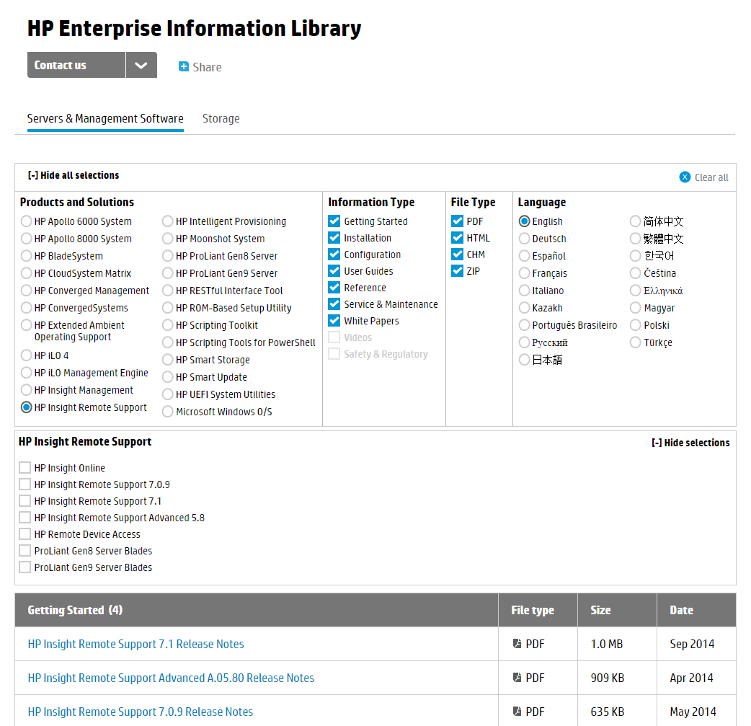

https://h20392.www2.hp.com/ecommerce/efulfillment/jsp/display_product_content.jsp?productNumber=REMOTESUPPORT&revision=2.0&contentType=terms

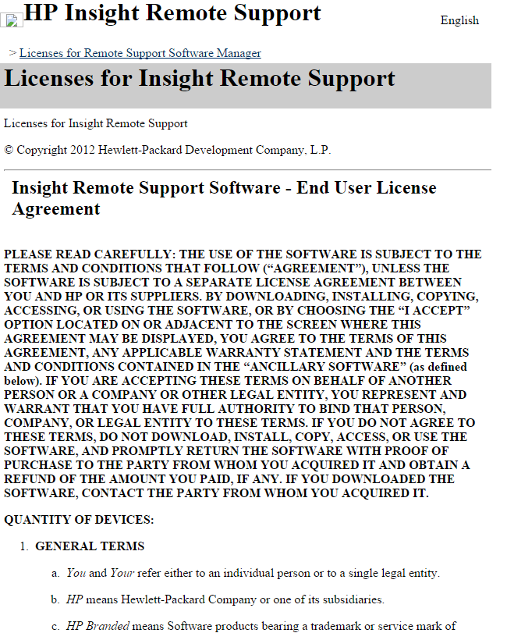

HP Insight Remote Support 7.1 Help
http://h17007.www1.hp.com/docs/enterprise/servers/InsightRS/webhelp/InsightRSHelp.htm

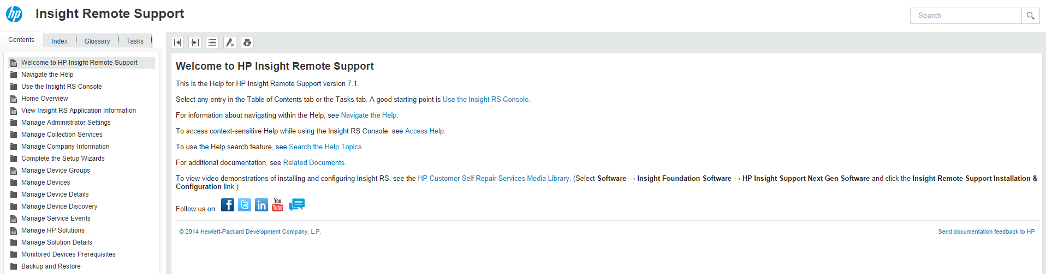

Microsoft Windows Server 2008 с пакетом обновления 2 для x64
Enterprise Edition

16GB RAM
50GB HDD.

.NET Framework 3.5.x

Администраторам виртуальных сред vmware.

Прошу создать две виртуальные машины согласно следующему описанию.

1. название проекта: название, ключевые слова, связки - короткое описание, для ссылок и именований.
1.1. IRS - HP Insight Remote Support.

2. краткое описание: достигаемая техническая цель, связь с бизнес-целью.
2.1. Отслеживание состояния оборудования серверов Hewlett Packard и уведомление служб технической поддержки вендора о неполадках.
2.2. Обеспечение SLA для бизнес-приложений, работающих на серверах.

3. ответственный сотрудник: сотрудник, который курирует финальные сроки проекта, определяет факт сдачи проекта, либо задает цели и сроки отдельно взятой части проекта.
3.1. Белогруд С.В.

4. схема потоков данных приложения: какие входные-выходные данные, из каких приложений, систем:
4.1 Информация о состоянии оборудования физических серверов HP собирается сервером IRS.
4.2. Важные уведомления о неисправностях оборудования пересылаются службе технической поддержки вендора HP.

5. схема сетевого взаимодействия: кто, из каких сетей будет обращаться к серверу, направления, протоколы, порты
5.1. Сервер должен быть доступен из локальной сети по протоколам http (port 80) и https (port 443) для доступа к прикладному ПО.
5.2. Сервер IRS обменивается данными со специально выделенным сервером вендора - services.isee.hp.com по протоколу https.
5.3. Сервер IRS должен иметь доступ к интерфейсам iLO серверов HP для сбора данных о состоянии оборудования.

6. имя (hostname сервера): формируется по правилам именования, с учетом площадки, функционала
6.1. vm-irs01t
6.2. vm-irs01p

7. ОС и количественные характеристики: ОС, цпу, память, диски - количество, параметры производительности (iops). Желательно в виде требований к ПО и обоснованные. Иначе, разворачивание из шаблонов по умолчанию.
7.1. Используемая ОС - Microsoft Windows Server 2008 с пакетом обновления 2 для x64 (Enterprise Edition).
7.2. Объём RAM - 16 GB.
7.3. Объём HDD - 50 GB.

8. ответственный пользователь сервера: сотрудник, который отвечает за функционал сервера, за получение оповещений от системы мониторинга, за согласование плановых работ и downtime сервера в случае необходимости
8.1. Белогруд С.В.

9. параметры доступности, мониторинга и оповещений (по умолчанию: без мониторинга): aka SLA - 8x5, 24x7. То же и про оповещения. Список метрик мониторинга, кроме "по-умолчанию".
9.1. Доступность 24x7.
9.2. Основные базовые параметры мониторинга серверов в nagios.

10. решение для DR: решение по "восстановлению после катастрофы", с указанием допустимой недоступности сервиса. Например - восстановление из бекапов, кластерное решение из более чем 1-го узла - actice-active, active-backup, балансировщики и т.п.
10.1. Обеспечение Disaster Recovery средствами восстановления из резервных копий.

11. решение для резервного копирования, восстановления (по умолчанию: без резервного копирования):
в случае необратимых логических ошибок в ПО, либо по требованию восстановления на указанную дату, с указанием глубины и времени восстановления
- нужно или нет
- вся файловая система или конкретные диски, состояние системы
- стандартное хранение копий (бэкап раз в день в 23-00, хранение копий 2 недели) или особые требования.
11.1. Стандартное резервное копирование виртуальной машины средствами vmware vSphere.

12. согласование с сетевым отделом, выделение сетей: создание новых сетей, или размещение в существующих
12.1. Сервер vm-irs01t разместить в сети, выделенной для тестовых серверов.
12.2. Сервер vm-irs01p разместить в сети, веделенной для production серверов.

13. согласование с руководителем: согласование с непосредственным руководителем
13.1. Руководитель - Терентьев А.Н.

14. согласование с ИБ: pci dss, доступы по сетевом взаимодействию
14.1. Отсутствует необходимость в pci dss.

15. срок: время "пилота", тестирования, проекта, ну или - навсегда
15.1. На постоянный срок.

